**KGiSL Microcollege,Coimbatore – 641035**

**Software Programming**

**Integrating GIT in VS Code**

Step 1: Open a Visual Studio Editor.

Step 2: Click the Source control

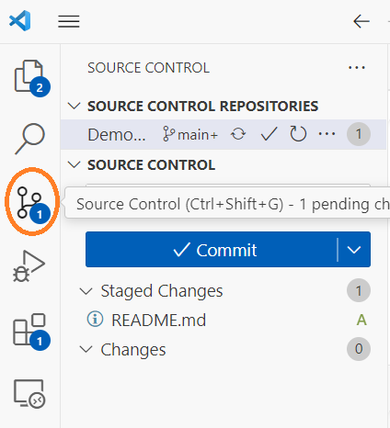

Step 3: Click the Source control … to clone the repository from Github, before that you must have Github account and create a global repository for cloning into VS code.

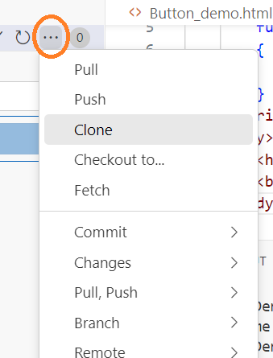

Step 4: Click the clone from GitHub and select your repository.

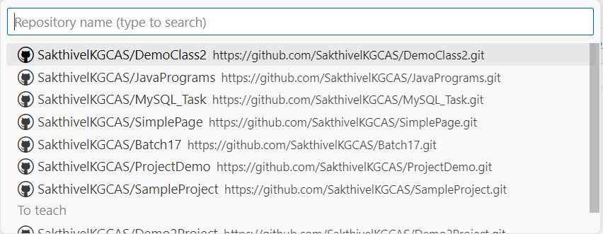

Step 5: Select the folder for cloning your repository

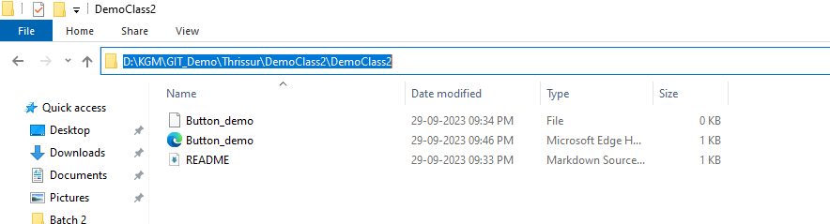

Step 6: To open a new window and create a new file for new program and save with extension

Step 7: Git Configuration, Goto terminal and type the configuration command.

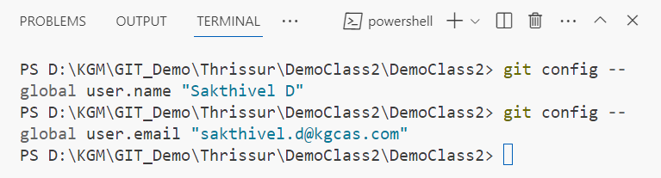

Step 8: Goto source control and click commit before that type the message for commit.

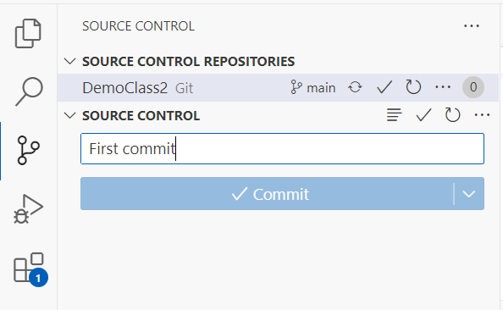

Step 9: Then click the Push command from source control to push your code to GitHub

Step 10. Open GitHub and see all your commits.

